Report for Big Data Analysis
FINAL PROJECT REPORT
Topic: Comprehensive Analysis of E-Commerce Transactional and Customer Data

Group’s members: Mukhamedali Nurislam, Makulbek Alisher,
Mukashev Rashid
Date: 26.12.2025

Introduction
This project presents a comprehensive analytical workflow applied to real-world e-commerce data, combining transactional records with customer-level demographic and behavioral attributes. The primary objective is to extract business insights, build predictive and descriptive models, and demonstrate practical data science skills using Python.
Two datasets were analyzed:
- Transactional data capturing orders, revenue, profit, discounts, logistics, and time information;
- Customer data describing demographics, job-related characteristics, income, and satisfaction indicators;
The analysis follows industry-standard practices, from data cleaning to modeling and business interpretation.

Task 1. Data Loading and Cleaning
1. Data Import and Structure Inspection
Both datasets were loaded using Python data analysis libraries. Initial inspection included checking dimensions, data types, and column consistency.
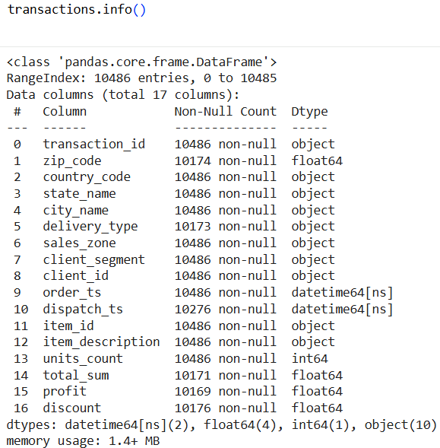
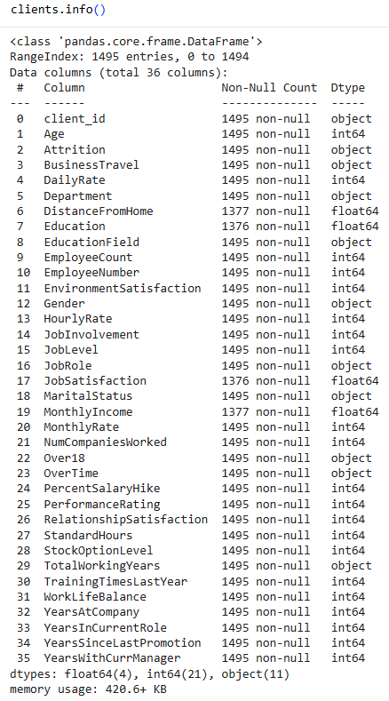

2. Missing Values Handling
Missing values were identified across numerical and categorical variables. The following strategies were applied: Numerical features( imputation using median values to reduce sensitivity to outliers), categorical features( imputation using mode or explicit "Unknown" category.)
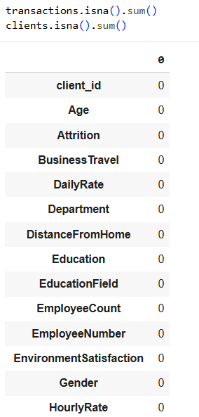
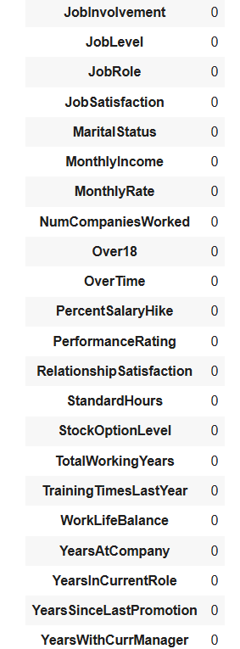
3. Outlier Detection and Treatment
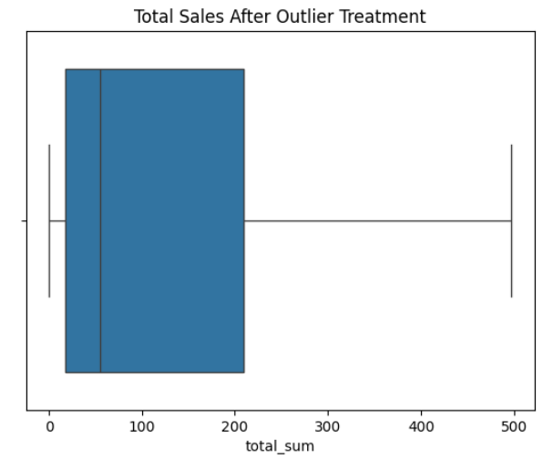
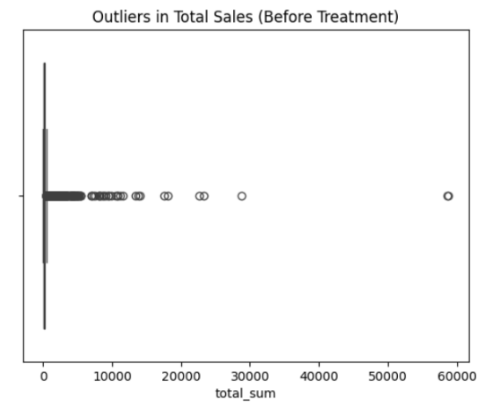
Outliers were detected using statistical methods (IQR and z-score) and visual inspection (boxplots). Extreme values in revenue, profit, and income-related features were winsorized to preserve data integrity without removing observations.

4. Categorical Normalization
Inconsistent categorical labels (e.g., case sensitivity, spelling variants) were standardized to ensure correct grouping and aggregation.
5. Data Type Corrections and Duplicates
Date columns were converted to proper datetime formats. Numeric columns were cast to appropriate types. Duplicate records were identified and removed based on unique identifiers.
6. Logical Consistency Checks
Logical errors such as negative quantities, impossible profit values, and invalid discounts were corrected or removed. Result is Two clean, analysis-ready datasets.
Task 2. Exploratory Data Analysis (EDA) and Visualization
1. Descriptive Statistics
Key descriptive statistics (mean, median, standard deviation, quartiles) were computed for sales, profit, quantity, and customer income variables.
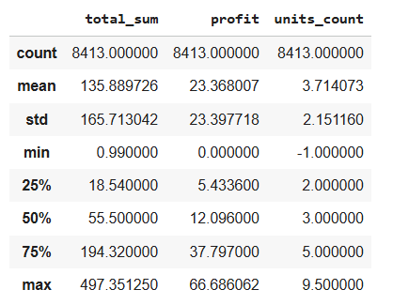
2. Revenue and Profit Distribution
The distribution of revenue and profit shows right-skewness, indicating the presence of high-value transactions contributing disproportionately to total sales.
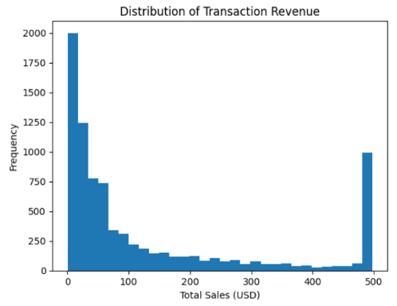
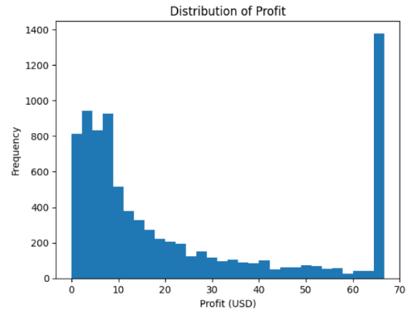

3. Time-Based Sales Trends
Sales were aggregated over time to identify seasonal patterns and overall trends. The analysis revealed fluctuations aligned with business cycles and promotional periods.
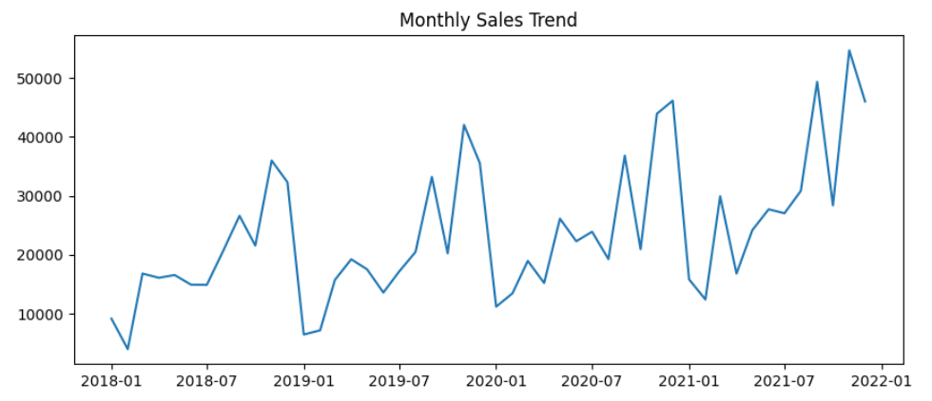
4. Customer Segment Comparison
Revenue and profitability were compared across customer segments and sales zones, highlighting differences in purchasing behavior.
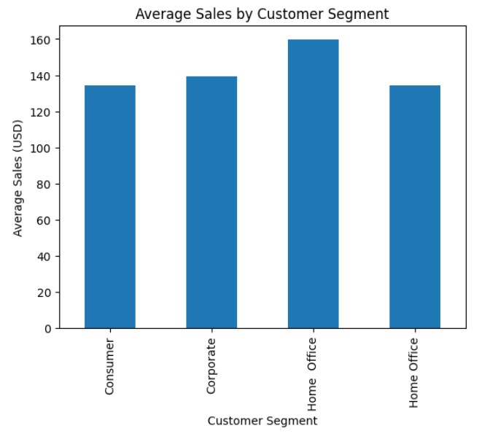
Task 3. Time Series Analysis and Forecasting
1. Data Aggregation
Transactional data was aggregated at a monthly level to model sales dynamics over time.
2. Stationarity Testing
An Augmented Dickey-Fuller (ADF) test was conducted to assess stationarity. Differencing was applied where necessary.
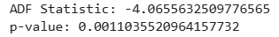

3. ACF and PACF Analysis
Autocorrelation and partial autocorrelation plots were used to guide model selection.
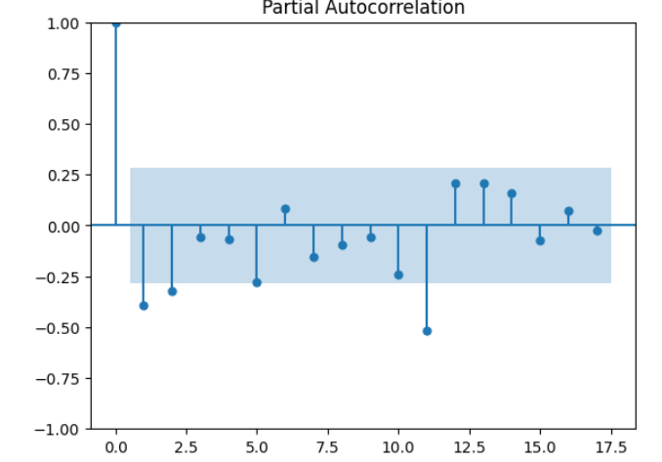
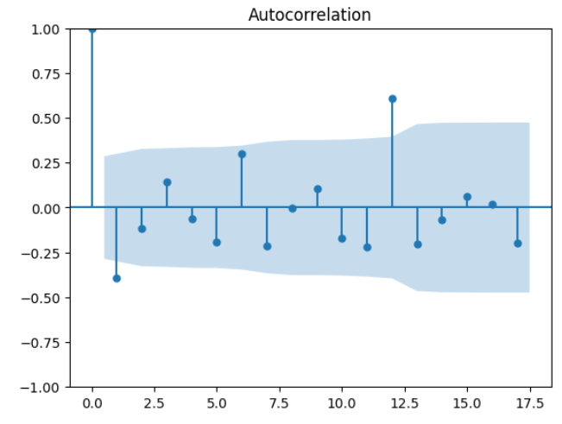

4. Model Fitting and Forecasting
An ARIMA/SARIMA model was fitted to the data based on observed patterns. The model was used to forecast the next 12 periods.
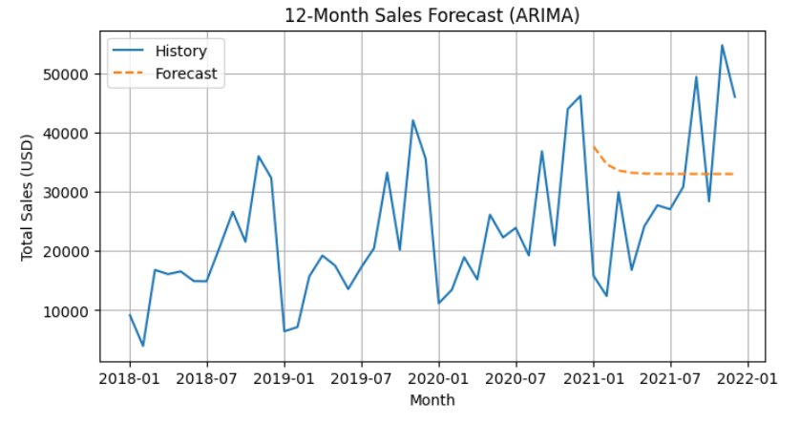
5. Forecast Evaluation
Forecast accuracy was evaluated using RMSE and MAE metrics.
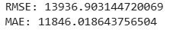

Task 4. Unsupervised Learning: Customer Segmentation
1. Feature Selection and Preprocessing
Relevant numerical and categorical features were selected from the customer dataset. Categorical variables were encoded, and numerical features were scaled.
2. Clustering Approach
K-means clustering was applied. The optimal number of clusters was determined using the elbow method and silhouette score.
But hierarchical clustering was selected as the preferred unsupervised learning method because it provided clearer structural insight into the data compared to alternative clustering approaches. Unlike K-means, hierarchical clustering does not require the number of clusters to be defined in advance, which is especially useful when the true cluster structure is unknown.
The dendrogram visualization played a key role in this decision. It clearly illustrated how observations were merged step by step and showed natural separation points at higher linkage distances. These visible gaps in the dendrogram indicated a stable and interpretable number of clusters, which could be selected objectively by cutting the tree at an appropriate height.
Additionally, when the hierarchical clustering results were visualized using PCA, the resulting clusters appeared more compact and better separated than those produced by K-means or DBSCAN. This visual separation supports the conclusion that hierarchical clustering captured meaningful relationships between customers more effectively.

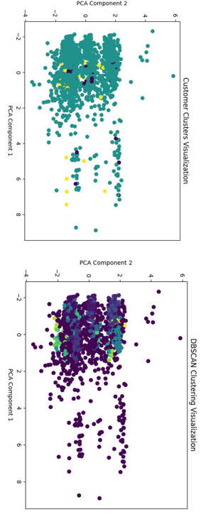
Clustering Visualization Interpretation
The PCA visualization for K-means shows strong overlap between clusters, with most points concentrated in the same area. This indicates weak separation between customer groups.
The DBSCAN visualization shows that most observations are assigned to one cluster, while many points are labeled as noise. This suggests that DBSCAN does not handle the data structure well in this case.
The hierarchical clustering visualization shows clearer separation between clusters. One cluster is visibly separated along the first PCA component, while the others are more compact. This indicates better structure and interpretability compared to the other methods.
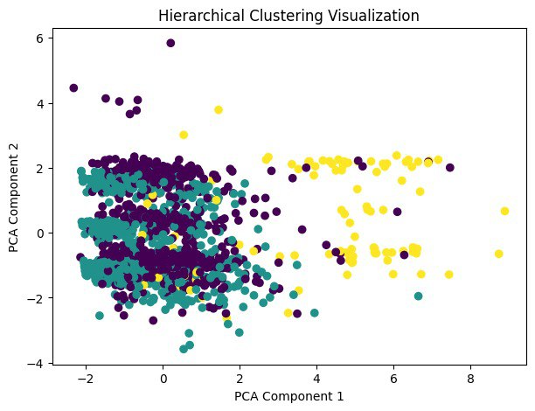
Overall, the combination of dendrogram-based cluster selection and clearer visual separation in PCA space justifies the choice of hierarchical clustering as the most suitable method for this dataset.
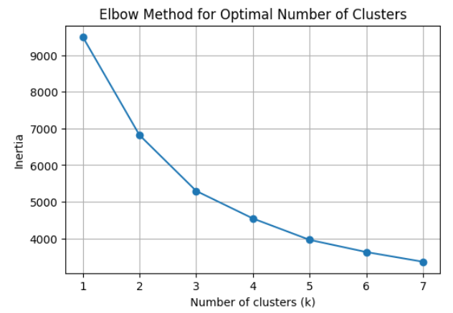

3. Cluster Profiles
Each cluster was analyzed based on income, job level, satisfaction, and purchasing behavior.
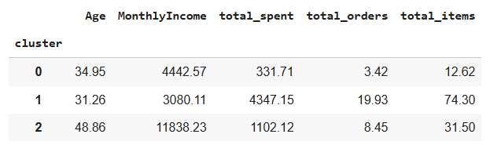
4. Business Interpretation
The clusters represent distinct customer segments, enabling targeted marketing and personalized strategies.

Task 5. Predictive Modeling: Customer Purchase Propensity
1. Target Variable Definition
A binary target variable was defined based on historical purchases of a selected product category.
2. Feature Engineering
Transactional data was aggregated to the customer level and merged with demographic features.
3. Model Training and Evaluation
A classification model (e.g., Logistic Regression / Random Forest) was trained using a train-test split.
Metrics like: Accuracy, Precision, Recall, F1-score, ROC-AUC evaluated
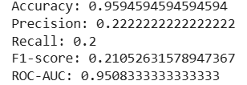
4. Results Interpretation
The model demonstrates reasonable predictive power, identifying key factors influencing customer purchase behavior.

Task 6. Final Interpretation and Business Conclusions
Key Insights
- Sales are driven by a small proportion of high-value transactions.
- Customer demographics and job-related attributes significantly influence purchasing behavior.
- Time series models provide useful short-term demand forecasts.
Model Reliability
While the models show solid performance, results depend on data quality and feature availability.
Business Recommendations
Targeted marketing strategies can be implemented by using the identified customer segments. Demand forecasts can be used to support inventory management and logistics planning. Retention strategies should focus on high-value customer clusters to maintain long-term profitability.

Conclusion
This project demonstrates a full analytical pipeline from raw data to actionable business insights. The applied methods align with real-world data science practices and provide a strong foundation for data-driven decision-making.
References
- Practical lessons
- Syllabus from Big Data Analysis course
- Pandas, NumPy, Scikit-learn libraries
- Statsmodels Time Series Analysis

